Salary Analysis Project

1. Project Overview
This project focuses on analyzing employee salary data. The workflow includes data cleaning using Python, data storage and querying using SQL, and data visualization through a dashboard.

2. Data Cleaning Using Python
The dataset was cleaned and prepared using Python and the Pandas library. The following steps were applied:
- Loaded the dataset using pandas.read_csv().
- Explored the dataset using head(), info(), and describe().
- Standardized column names to lowercase.
- Renamed salary_usd to salary and bonus_usd to bonus.
- Created a new column total_compensation by summing salary and bonus.
- Categorized employees into age groups using pd.cut().
- Categorized employees into experience levels (Junior, Mid-level, Senior).

3. SQL Analysis
After cleaning, the data was imported into SQL Server for analysis. Several business questions were answered using SQL queries:
- Top 10 employees by salary.
- Average salary for each job title.
- Department with the highest average salary.
- Salary comparison between remote and on-site employees.
- Relationship between experience level and salary.
- Highest-paying nationalities.
- Average salary by contract type.
- Salary distribution by education level.
- Average salary by gender.
- Average performance score by department.
- Relationship between working hours and bonus.

4. Dashboard & Insights
A dashboard was created to visualize salary trends, experience impact, departmental performance, and compensation differences. These insights help stakeholders make informed HR and compensation decisions. 4. Dashboard & Insights

1. Overview

Here's the overview, and here are the KPIs: average salary, average bonus, number of employees, and average years of experience. The following chart shows the average salary in each department, and the next chart shows the average salary for each job. Here's a map showing the number of employees from different countries, and here's the percentage and number of men and women relative to the total.

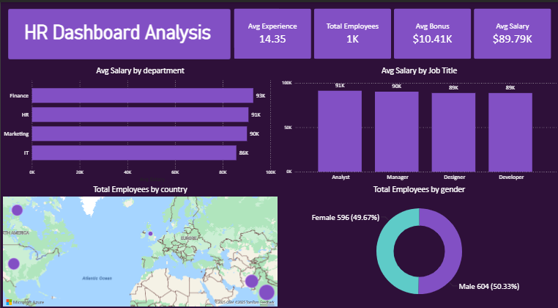

2. Salary & Performance Analysis
Here are the highest-paid employees, Box Plot — Salary Distribution, Average Salary by Contract Type, Scatter Chart — Salary vs. Experience/Performance Score, and Line Chart — Salary vs. Experience/Performance Score.
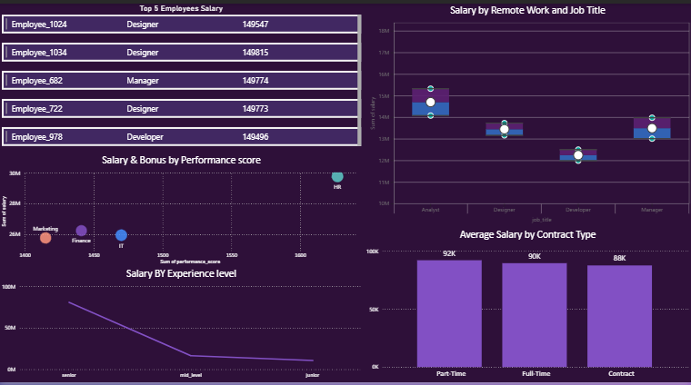

3. HR Insights
Here table has columns name , salary ,bonus , experience years and performance score + slicers country , department , contract type and gender to make filtration and Bar Chart — Performance Score by Department and TreeMap — Employees by Job Title .
